JOUR 4251 Personalization (part 1)
What is personalization in advertising?
The strategic creation, modification, and adaptation of content and distribution to optimize the fit with personal characteristics, interests, preferences, communication styles, and behavior.

Personalization strategies
● Email marketing
● Online behavioral advertising
● Social media advertising
● Apps and notifications
● On-site personalization
○ Recommender systems
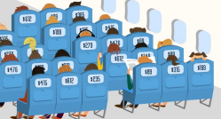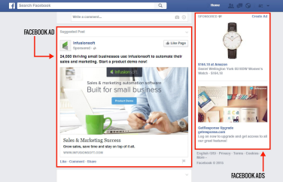
● Customization
● Price differentiation
Data is needed!
First party data Second party data Third party data
Data owned by companies about their own customers (i.e., survey, website visits).
Ex. website visit, Facebook interactions
Privacy paradox
Any data that gets relayed along the media buying activities.
Ex. user device model, location, OS version
Data purchased on a massive scale from data management platforms.
Ex. pay publishers to let it collect info about their visitors.

Although some people are worried about their privacy, they do not act like it (e.g., they disclose their information instantly and almost unconditionally).
Why?
Data is needed!
Deterministic data Probabilistic data
That you can easily determine based on available data.
That you can infer based on available data.
2 + 2 = 4 2 + x = y
Want to know what data is collected?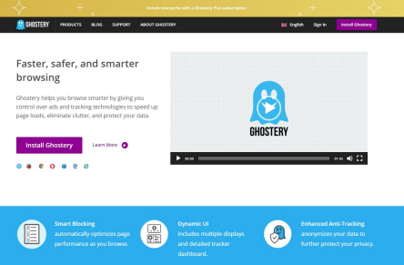
When does it work?

Personalization paradox Personalization has positive and negative effects.
Privacy calculus theory
Personalization is effective when the benefits outweigh the costs.
Why does it work?
Self-referencing theory
Personalization creates a match between message and recipient. People like things that are related to themselves. BUT
When too self-related it can backfire.
● Too creepy
● Increase scrutinization (ELM!)
What’s next?
This week:
● Submit reading response #10
○ Articles: Strycharz et al (2019) + Segijn (2019) ○ Deadline: April 16, 2:30 pm
● Submit review question by April 16, 2:30 pm Next week:
● Assignment #4
○ We discussed all contents needed for this assignment ○ Deadline: April 23, 2:30 pm
Student Rating of Teaching by May 3

